**CITRON** Laser Electro-optics

Test and Measurement Station.

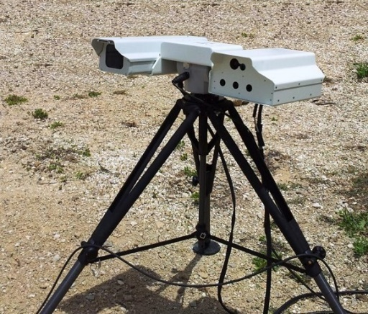 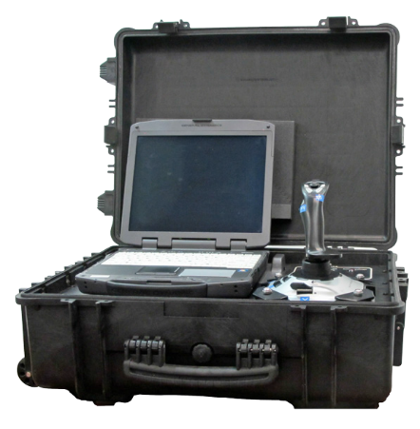

The CITRON is a laser and electro-optical test and measurement station for long range evaluation and measurement of cameras, sensors and detector under influence of atmospheric and environmental effects. CITRON tests capabilities include testing of the most advanced thermal cameras operating in the MWIR (3-5um) spectral range.

CITRON provides fast and safe testing by emission of programable laser radiation sequence or waveform, based on input parameters such as: amplitude, pulse width, repetition rate, duty cycle, intensity, divergence and likes. In addition, CITRON simulates effects of atmospheric disturbances and atmospheric transmission for convenient testing.

CITRON includes video tracker with motorized pedestal, laser rangefinder, MWIR programmable laser simulator, computer, tripod and a portable battery. CITRON records data and video backlog of events for post analysis

The CITRON is available for measurements and simulations at various laser wavelengths including MWIR, NIR, SWIR, LWIR, UV. Integrated detectors of CITRON measure backscattered radiation. Tandem operation of two CITRON station allows bi-directional measurement of laser signals transmitted via atmosphere.

The CITRON can be used for remote sensing of atmosphere contaminations and for pollution control via measurements of absorption and scattering of the laser radiation by the pollutions, smog and dust. The equipment can be used as free space optical link for distances of 1km to 20km (direct line of sight) having appropriate laser transceiver module in use. Two stations are required for the link.

|  |  |
| --- | --- |
| **FEATURES**  Proven in field use. One man portable  Affordable cost. Cost effective  Low Maintenance. Passive cooled  Withstands field environmental conditions | APPLICATIONS  Long Range Testing of cameras and sensors in real atmospheric conditions.  Atmosphere measurement and Pollution control  Free space communication optical link simulation and development |

|  |  |
| --- | --- |
| LASER TEST STATION MODEL：CITRON MAIN PARAMETERS, | |
| Wavelength range | MWIR (UV, NIR, SWIR, LWIR – optional) |
| Beam divergence (deg) | 1-2 |
| On-Axis Radiant Intensity (Watt/str) max | 500 - 1,000 |
| IR rise/fall time (msec) | 0.1 |
| IR programming step (msec) | 1 |
| Single engagement dynamic range | > 800 |
| Standoff range (m) | 5 - 6,000 |
|  |  |
| Gimbal Travel Range Azimuth / Elevation | 360° (+/-180°) / 60° (+50°/-10°) |
| Gimbal Travel Rate / Follow Aim Rate (°/sec) | 30 / 15 |
| Gimbal Position Resolution, mrad | 0.1 |
|  |  |
| Tracker Camera | Color 2/3 CCD HD 1920 x 1080, 60 fps |
| Tracker Zoom | x30 optical, (x3 digital) |
| FOV horizontal | 45° – 1.5° (15° - 0.5°) |
|  |  |
| Rangefinder Repetition rate | 1pps |
| Rangefinder Range, m | 100 – 10,000 |
| Rangefinder Eye safety category | Class 1M IEC 825-1 2001-08 |
|  |  |
| Clear aperture, mm | Laser transmitter < 30 x 150  Rangefinder < 40 x 100  Tracker camera < 70 x 70 |
| Warm-up time (min) | < 2 |
| Environmental | 5 - 45°C |
| Weight (kg) | Optical assembly – 20  Tripod – 10  Control unit – 10 |
| Power input from Battery or AC/DC adapter | DC 24V ( 3 - 10A) |

Specifications in this document are subject to change without notice.

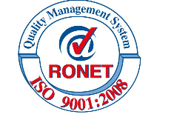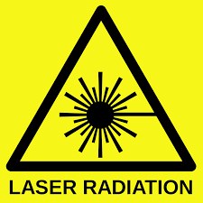

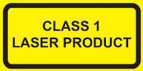

Alternative configuration of the product, having different form factor and additional transmitting and receiving channels.

Figure: Configuration for Ground to Ground Free Space Optical Communication Link

Figure: Configuration for atmosphere pollutions control

